**ASP.net Notes**

**Week#01 20-02-2024**

**ASP.Net Full stack Foundation (2nd week)**

**Introduction to C#**

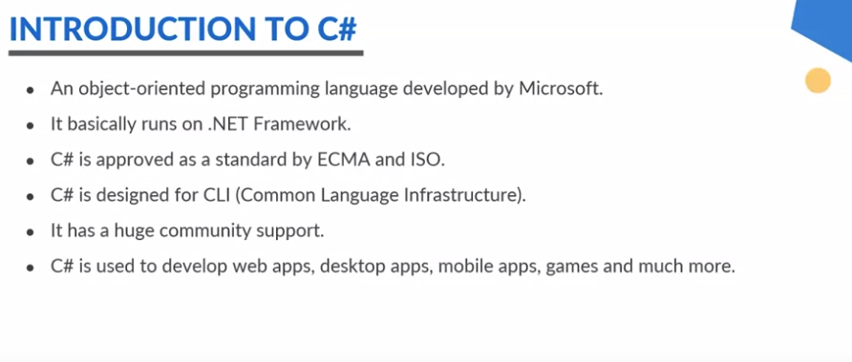

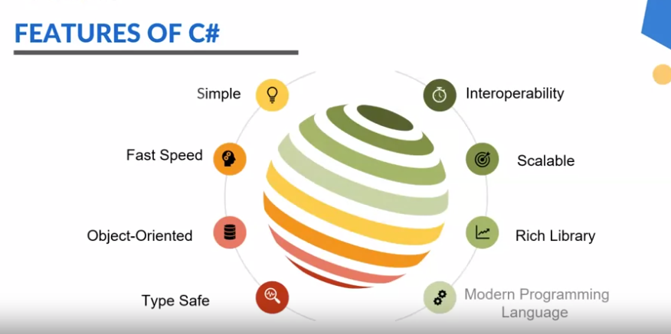

**History**

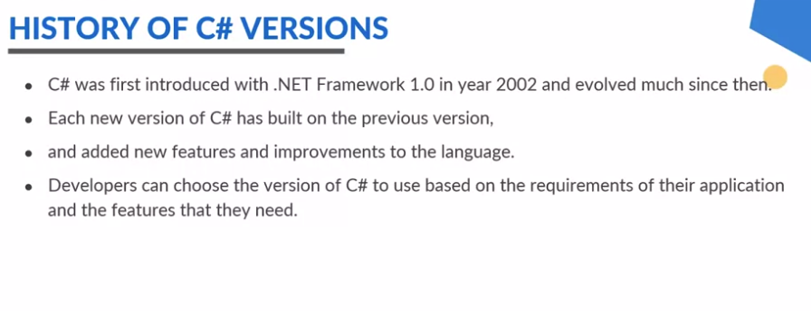

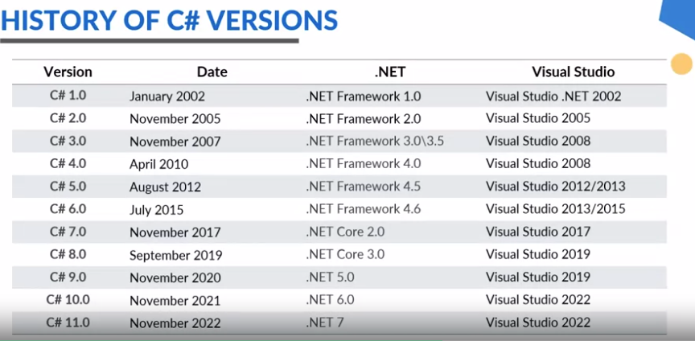

**C# Code Execution**

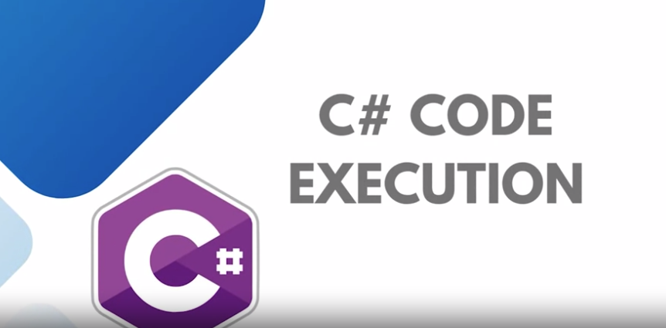

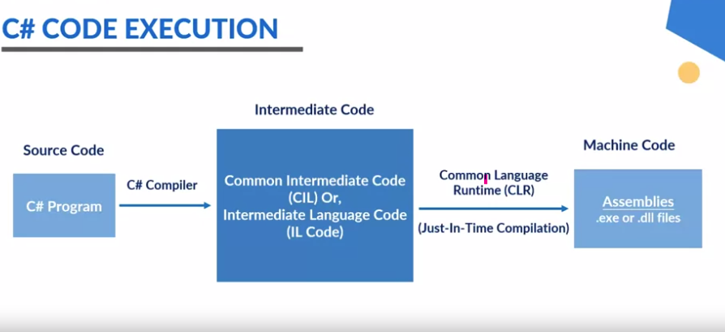

**Installing and Configuring Visual Studio**

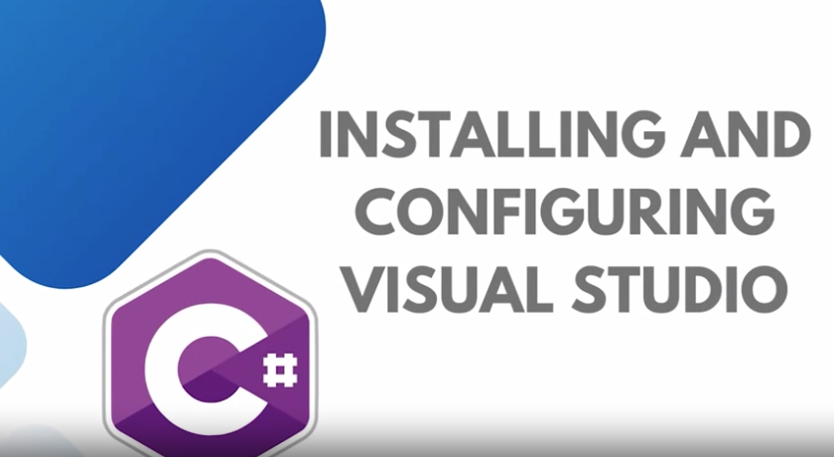

**Here are steps:**

-First download Microsoft visual studio set up and

-Install the all packages here you want and it configured.

**--------------------------------------**

**Variables and Data Types**

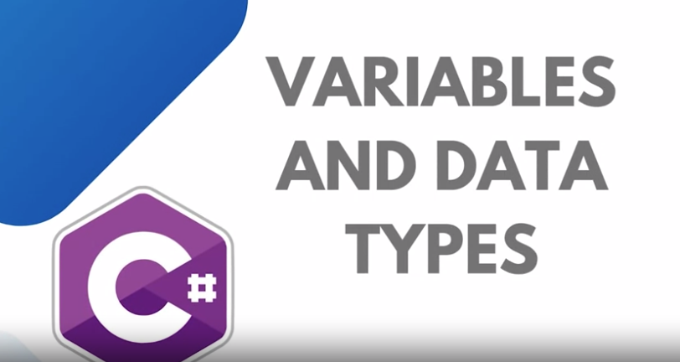

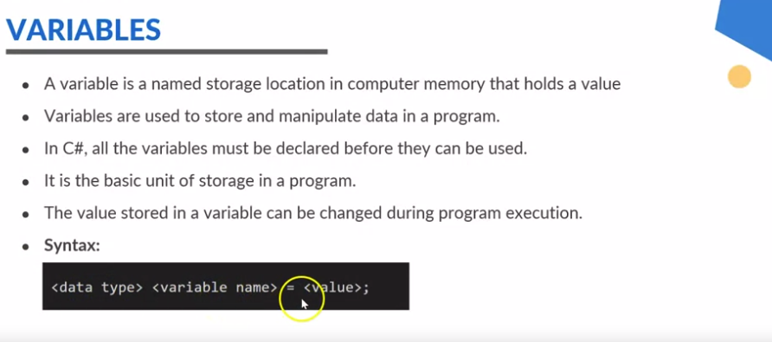

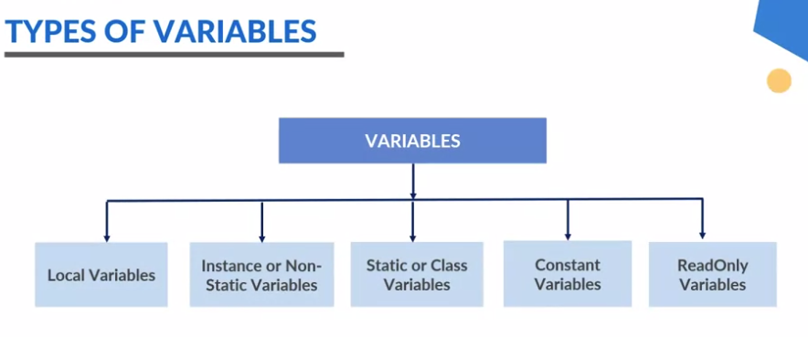

**Local:**

**Static:** Used only when we work with classes.

**Non-static:** Objects Used everywhere not any specification.

**Constant:** Used only forConstant value.

**ReadOnly:**

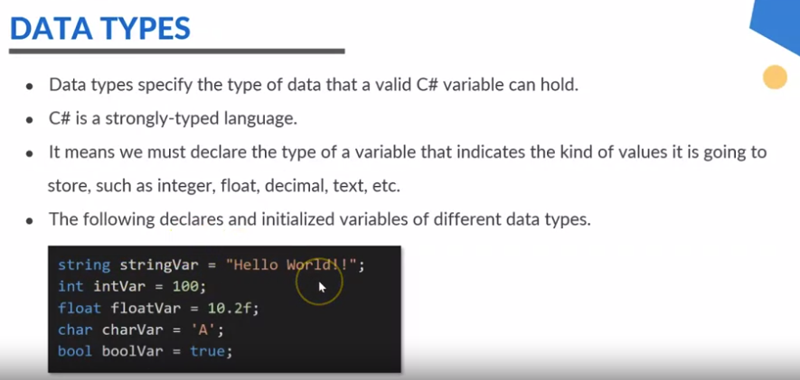

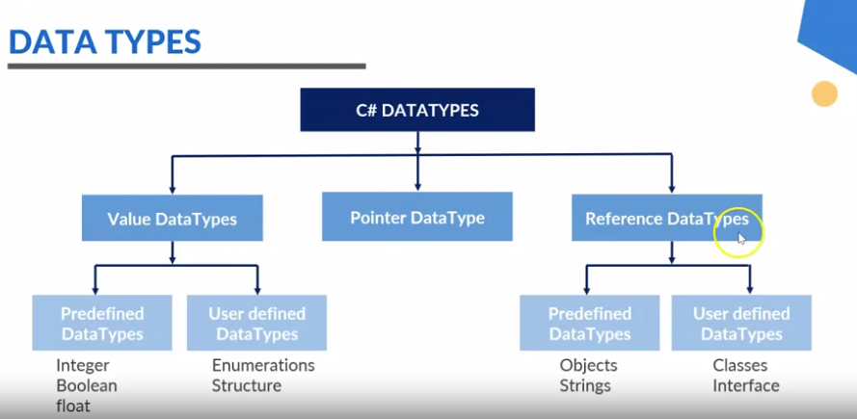

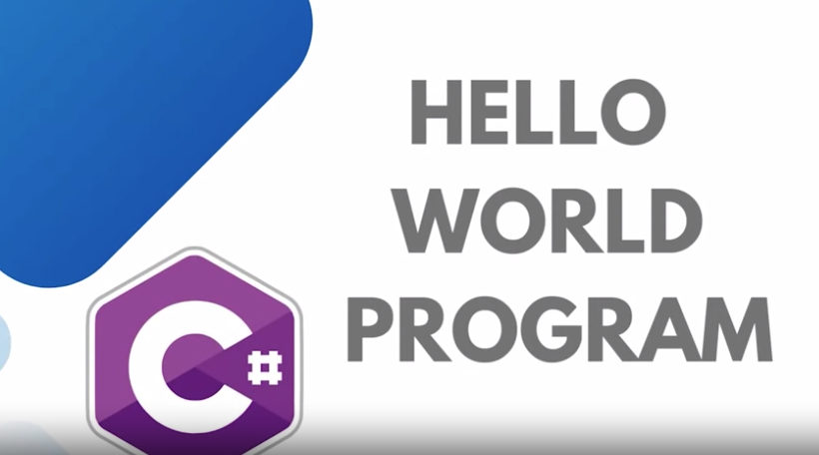

**24-02-2024**

**C# Conditionals and Loops**

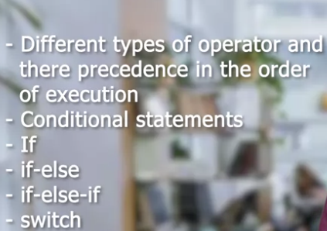

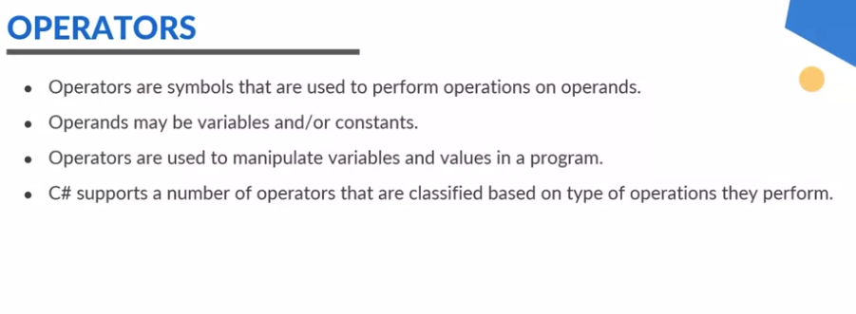

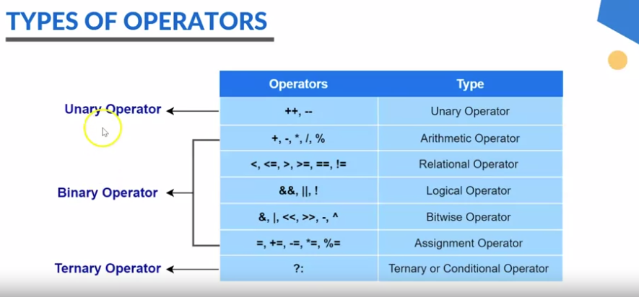

**Here is practice program:**

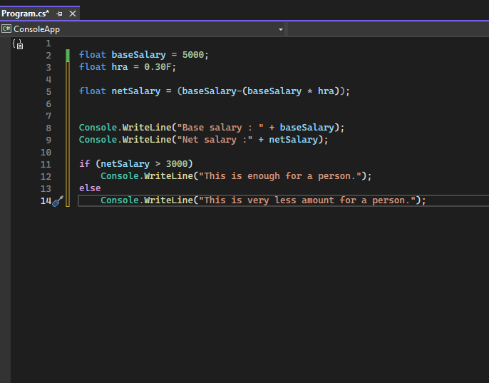

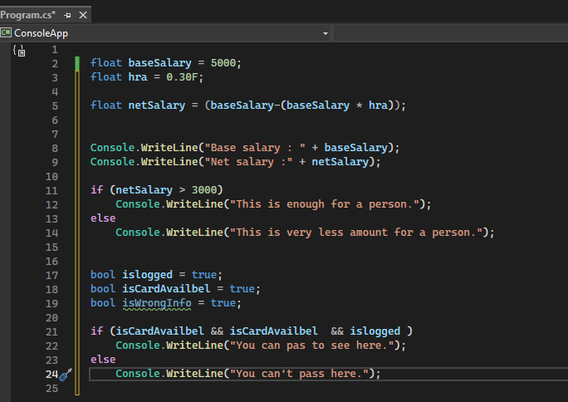

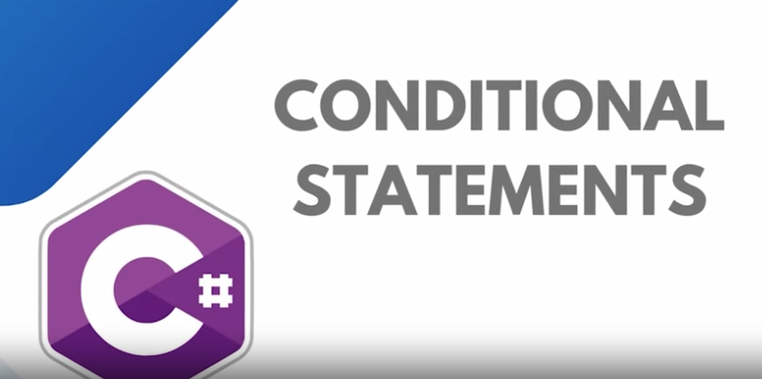

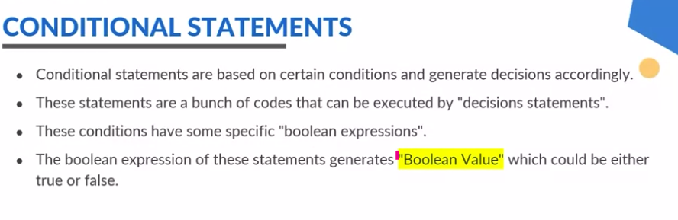

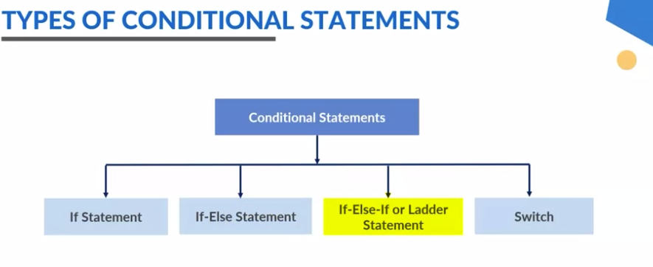

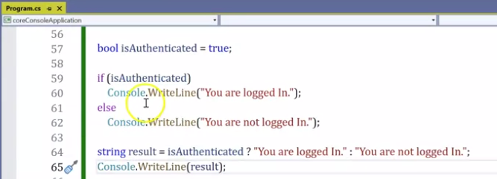

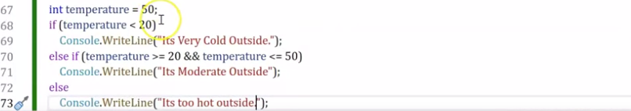

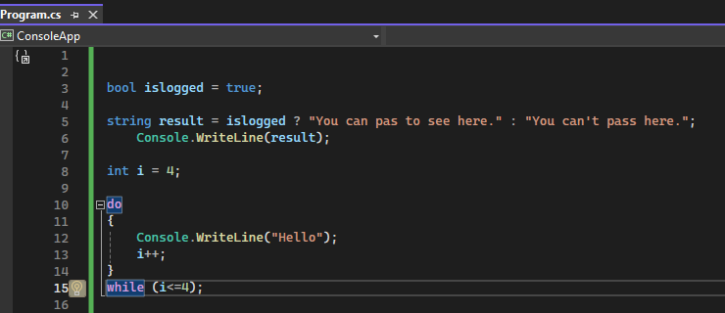

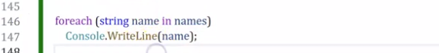

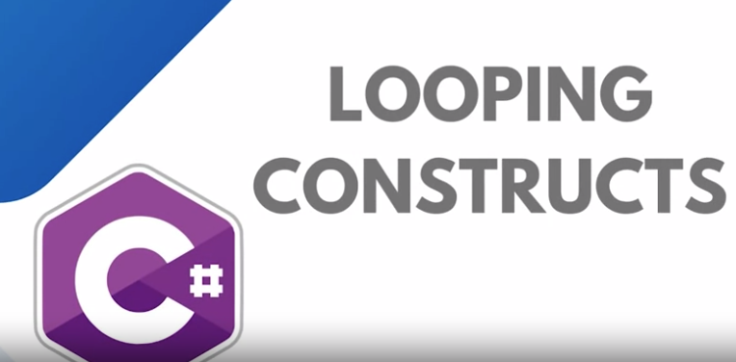

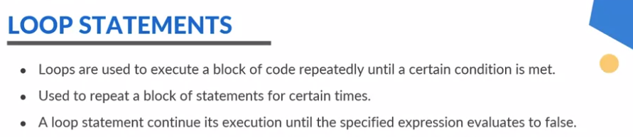

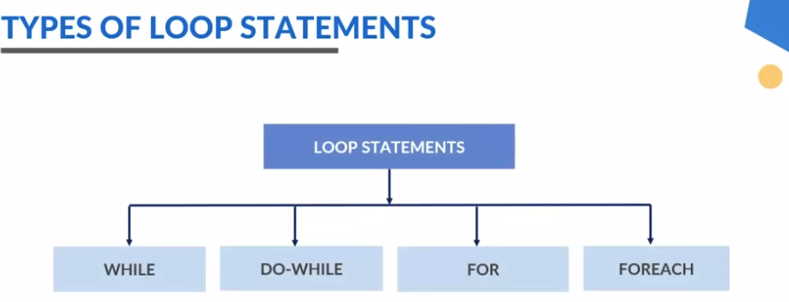

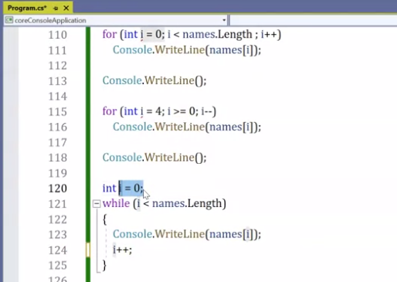

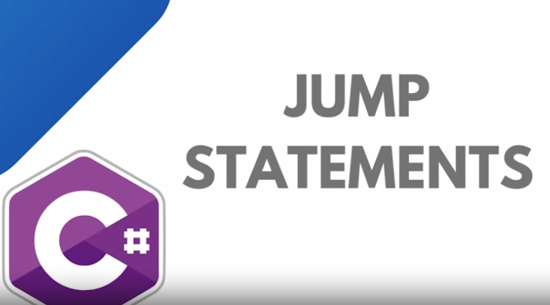

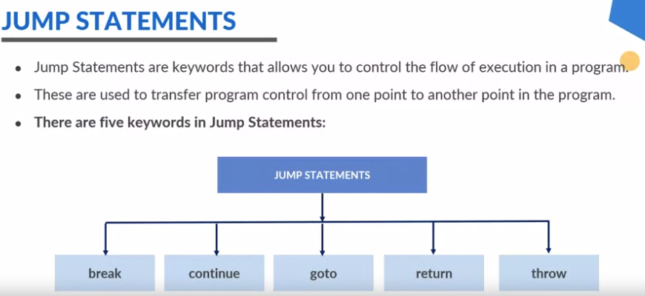

**Break:** statement helps us to terminate the loop or statement in which it is present.

**Continue:** statement helps us to skip over the execution part of the loop on a certain condition.

**Goto:** statement is used to transfer the control to the label statement in the program.

**Return:** statement terminates the execution of the method and returns the control to the calling method

**Throw:** is used to create an object of any valid exception class with the help of new keyword manually.

